Detailed Design

for

Tourist Assistor System (TAssist)

Version 1.0 approved

Prepared by Naeema Binthe Ashraf & Mahfujur Rahman Afnan

Khulna University

25 October,2018

# ER Diagram

This is the ER diagram of our project done by MySQL Workbench.

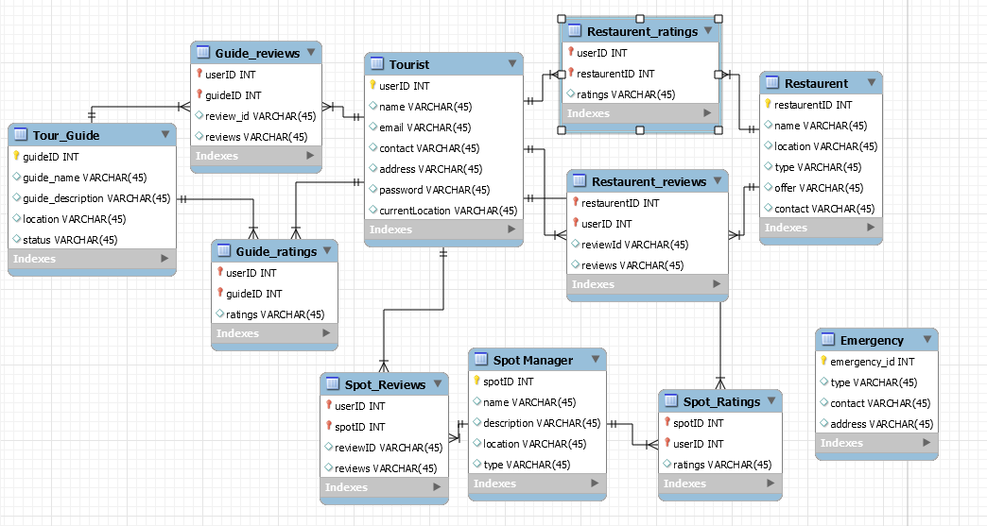

Figure: ER Diagram

# Class Diagram

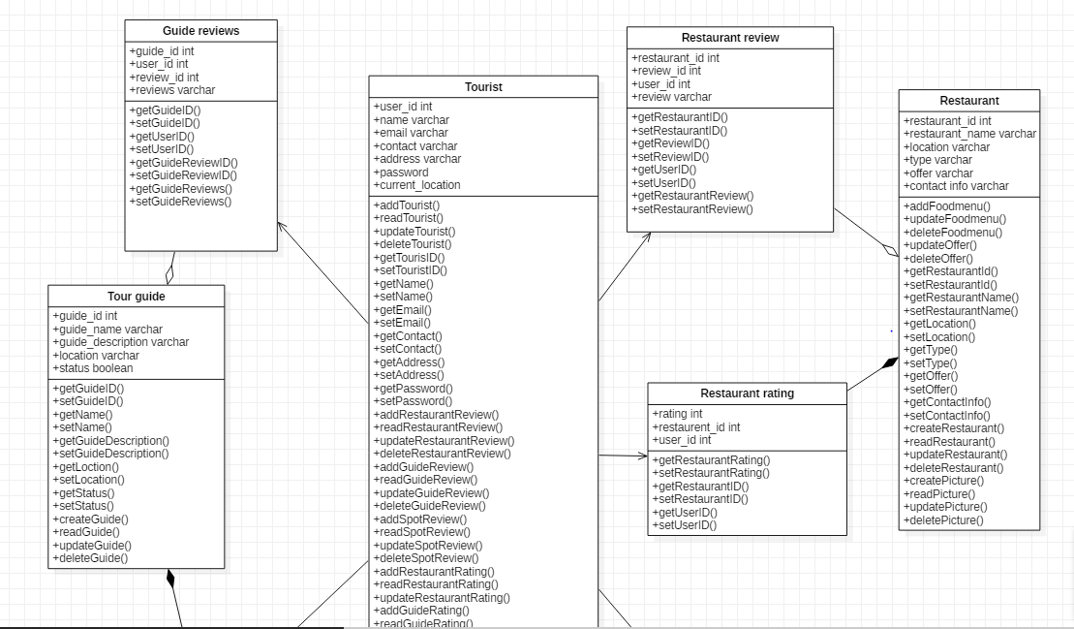

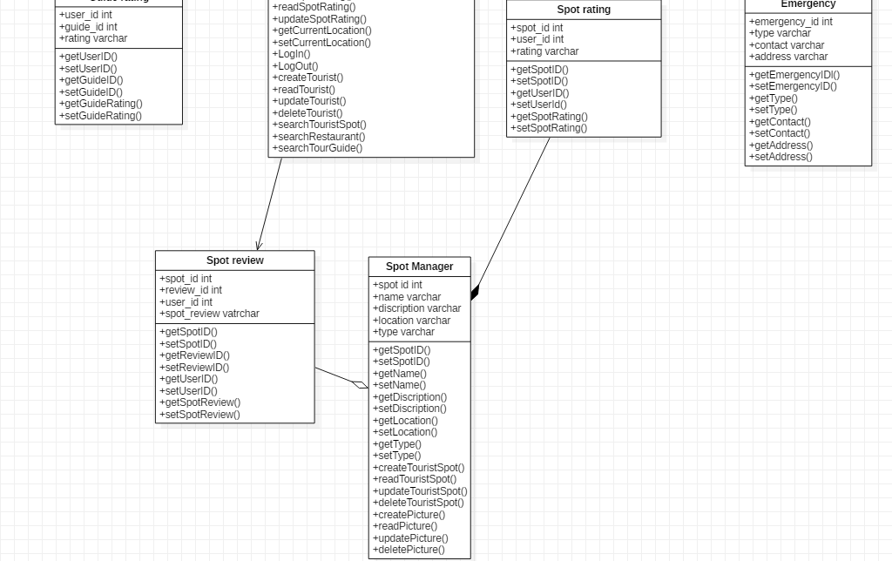Figure: UML Diagram

# Class Diagram Details

**Tourist:**

boolean logIn(String ID)

boolean createTourist (Tourist)

Tourist readTourist(String ID)

boolean updateTourist(Tourist)

boolean deleteTourist(Tourist)

Restaurant searchRestaurantbyID(String ID)

List<Restaurant> searchRestaurantbyArea(String location)

TourGuide searchTourGuidebyID(String ID)

List<TourGuide> searchTourGuidebyArea(String location)

TouristSpot searchTouristSpotbyID(String ID)

List<TouristSpot> searchTouristSpotbyArea(String location)

RestaurantReview addRestaurantReview(int user_ID)

RestaurantReview readRestaurantReview(int user_ID)

boolean updateRestaurantReview(int user_ID)

boolran deleteRestaurantReview(int user_ID)

GuideReview addGuideReview(int user_ID)

GuideReview readRestaurantReview(int user_ID)

boolean updateRestaurantReview(int user_ID)

boolean deleteRestaurantReview(int user_ID)

TouristSpotReview addSpotReview(int user_ID)

TouristSpotReview readSpotReview(int user_ID)

boolean updateSpotReview(int user_ID)

boolean delete Tourist Spot Review(int user_ID)

RestaurantRating addRestaurantRating(int user_ID)

RestaurantRating readRestaurantRating(int user_ID)

boolean updateRestaurantRating (int user_ID)

GuideRating addGuideRating(int user_ID)

GuideRating readRestaurantRatingw(int user_ID)

boolean updateRestaurantRating(int user_ID)

TouristSpotRating addSpotRating(int user_ID)

TouristSpotRating readSpotRating(int user_ID)

boolean Rating updateSpotRating(int user_ID)

Restaurant readRestaurant(int restaurant_id)

TourGuide readTourGuide(int guide_id)

TouristSpot readTouristSpot(int spot_id)

boolean logout(String ID)

**Restaurant:**

boolean logIn(String ID)

boolean createRestaurant (Restaurant)

Restaurant readRestaurant(String restaurant_id)

boolean updateRestaurant(Restaurant)

boolean deleteRestaurant(Restaurant)

RestaurantReview readRestaurantReview(int restaurant_id)

RestaurantRating readRestaurantRating(int restaurant_id)

**TouristSpot:**

boolean createTouristSpot (Tourist_spot)

TouristSpot readTouristSpot (String spot_id)

boolean updateTouristSpot (Tourist_Spot)

boolean deleteTouristSpot (Tourist_Spot)

SpotReview read Spot Review(int Spot _id)

SpotRating read Spot Rating(int Spot _id)

**TourGuide:**

boolean logIn(String ID)

boolean createTourGuide (guide)

TourGuide readTourGuide (String guide_id)

boolean updateTourGuide (Tour_guide)

boolean deleteTourGuide (Tour_guide)

GuideReview read Guide Review(int guide _id)

GuideRating read Guide Rating(int guide _id)

# Database Script

-- MySQL Workbench Forward Engineering

SET @OLD_UNIQUE_CHECKS=@@UNIQUE_CHECKS, UNIQUE_CHECKS=0;

SET @OLD_FOREIGN_KEY_CHECKS=@@FOREIGN_KEY_CHECKS, FOREIGN_KEY_CHECKS=0;

SET @OLD_SQL_MODE=@@SQL_MODE, SQL_MODE='TRADITIONAL,ALLOW_INVALID_DATES';

-- -----------------------------------------------------

-- Schema mydb

-- -----------------------------------------------------

-- -----------------------------------------------------

-- Schema sqltas

-- -----------------------------------------------------

-- -----------------------------------------------------

-- Schema sqltas

-- -----------------------------------------------------

CREATE SCHEMA IF NOT EXISTS `sqltas` DEFAULT CHARACTER SET utf8 ;

USE `sqltas` ;

-- -----------------------------------------------------

-- Table `sqltas`.`emergency`

-- -----------------------------------------------------

CREATE TABLE IF NOT EXISTS `sqltas`.`emergency` (

`emergency_id` INT(11) NOT NULL,

`type` VARCHAR(45) NULL DEFAULT NULL,

`contact` VARCHAR(45) NULL DEFAULT NULL,

`address` VARCHAR(45) NULL DEFAULT NULL,

PRIMARY KEY (`emergency_id`))

ENGINE = InnoDB

DEFAULT CHARACTER SET = utf8;

-- -----------------------------------------------------

-- Table `sqltas`.`tour_guide`

-- -----------------------------------------------------

CREATE TABLE IF NOT EXISTS `sqltas`.`tour_guide` (

`guideID` INT(11) NOT NULL,

`guide_name` VARCHAR(45) NULL DEFAULT NULL,

`guide_description` VARCHAR(45) NULL DEFAULT NULL,

`location` VARCHAR(45) NULL DEFAULT NULL,

`status` VARCHAR(45) NULL DEFAULT NULL,

PRIMARY KEY (`guideID`))

ENGINE = InnoDB

DEFAULT CHARACTER SET = utf8;

-- -----------------------------------------------------

-- Table `sqltas`.`tourist`

-- -----------------------------------------------------

CREATE TABLE IF NOT EXISTS `sqltas`.`tourist` (

`userID` INT(11) NOT NULL,

`name` VARCHAR(45) NULL DEFAULT NULL,

`email` VARCHAR(45) NULL DEFAULT NULL,

`contact` VARCHAR(45) NULL DEFAULT NULL,

`address` VARCHAR(45) NULL DEFAULT NULL,

`password` VARCHAR(45) NULL DEFAULT NULL,

`currentLocation` VARCHAR(45) NULL DEFAULT NULL,

PRIMARY KEY (`userID`))

ENGINE = InnoDB

DEFAULT CHARACTER SET = utf8;

-- -----------------------------------------------------

-- Table `sqltas`.`guide_ratings`

-- -----------------------------------------------------

CREATE TABLE IF NOT EXISTS `sqltas`.`guide_ratings` (

`userID` INT(11) NOT NULL,

`guideID` INT(11) NOT NULL,

`ratings` VARCHAR(45) NULL DEFAULT NULL,

PRIMARY KEY (`userID`, `guideID`),

INDEX `fk_Tourist_has_Tour_Guide_Tour_Guide2_idx` (`guideID` ASC),

INDEX `fk_Tourist_has_Tour_Guide_Tourist1_idx` (`userID` ASC),

CONSTRAINT `fk_Tourist_has_Tour_Guide_Tour_Guide2`

FOREIGN KEY (`guideID`)

REFERENCES `sqltas`.`tour_guide` (`guideID`)

ON DELETE NO ACTION

ON UPDATE NO ACTION,

CONSTRAINT `fk_Tourist_has_Tour_Guide_Tourist1`

FOREIGN KEY (`userID`)

REFERENCES `sqltas`.`tourist` (`userID`)

ON DELETE NO ACTION

ON UPDATE NO ACTION)

ENGINE = InnoDB

DEFAULT CHARACTER SET = utf8;

-- -----------------------------------------------------

-- Table `sqltas`.`guide_reviews`

-- -----------------------------------------------------

CREATE TABLE IF NOT EXISTS `sqltas`.`guide_reviews` (

`userID` INT(11) NOT NULL,

`guideID` INT(11) NOT NULL,

`review_id` VARCHAR(45) NULL DEFAULT NULL,

`reviews` VARCHAR(45) NULL DEFAULT NULL,

PRIMARY KEY (`userID`, `guideID`),

INDEX `fk_Tourist_has_Tour_Guide_Tour_Guide1_idx` (`guideID` ASC),

INDEX `fk_Tourist_has_Tour_Guide_Tourist_idx` (`userID` ASC),

CONSTRAINT `fk_Tourist_has_Tour_Guide_Tour_Guide1`

FOREIGN KEY (`guideID`)

REFERENCES `sqltas`.`tour_guide` (`guideID`)

ON DELETE NO ACTION

ON UPDATE NO ACTION,

CONSTRAINT `fk_Tourist_has_Tour_Guide_Tourist`

FOREIGN KEY (`userID`)

REFERENCES `sqltas`.`tourist` (`userID`)

ON DELETE NO ACTION

ON UPDATE NO ACTION)

ENGINE = InnoDB

DEFAULT CHARACTER SET = utf8;

-- -----------------------------------------------------

-- Table `sqltas`.`restaurent`

-- -----------------------------------------------------

CREATE TABLE IF NOT EXISTS `sqltas`.`restaurent` (

`restaurentID` INT(11) NOT NULL,

`name` VARCHAR(45) NULL DEFAULT NULL,

`location` VARCHAR(45) NULL DEFAULT NULL,

`type` VARCHAR(45) NULL DEFAULT NULL,

`offer` VARCHAR(45) NULL DEFAULT NULL,

`contact` VARCHAR(45) NULL DEFAULT NULL,

PRIMARY KEY (`restaurentID`))

ENGINE = InnoDB

DEFAULT CHARACTER SET = utf8;

-- -----------------------------------------------------

-- Table `sqltas`.`restaurent_ratings`

-- -----------------------------------------------------

CREATE TABLE IF NOT EXISTS `sqltas`.`restaurent_ratings` (

`userID` INT(11) NOT NULL,

`restaurentID` INT(11) NOT NULL,

`ratings` VARCHAR(45) NULL DEFAULT NULL,

PRIMARY KEY (`userID`, `restaurentID`),

INDEX `fk_Tourist_has_Restaurent_Restaurent1_idx` (`restaurentID` ASC),

INDEX `fk_Tourist_has_Restaurent_Tourist1_idx` (`userID` ASC),

CONSTRAINT `fk_Tourist_has_Restaurent_Restaurent1`

FOREIGN KEY (`restaurentID`)

REFERENCES `sqltas`.`restaurent` (`restaurentID`)

ON DELETE NO ACTION

ON UPDATE NO ACTION,

CONSTRAINT `fk_Tourist_has_Restaurent_Tourist1`

FOREIGN KEY (`userID`)

REFERENCES `sqltas`.`tourist` (`userID`)

ON DELETE NO ACTION

ON UPDATE NO ACTION)

ENGINE = InnoDB

DEFAULT CHARACTER SET = utf8;

-- -----------------------------------------------------

-- Table `sqltas`.`restaurent_reviews`

-- -----------------------------------------------------

CREATE TABLE IF NOT EXISTS `sqltas`.`restaurent_reviews` (

`restaurentID` INT(11) NOT NULL,

`userID` INT(11) NOT NULL,

`reviewId` VARCHAR(45) NULL DEFAULT NULL,

`reviews` VARCHAR(45) NULL DEFAULT NULL,

PRIMARY KEY (`restaurentID`, `userID`),

INDEX `fk_Restaurent_has_Tourist_Tourist1_idx` (`userID` ASC),

INDEX `fk_Restaurent_has_Tourist_Restaurent1_idx` (`restaurentID` ASC),

CONSTRAINT `fk_Restaurent_has_Tourist_Restaurent1`

FOREIGN KEY (`restaurentID`)

REFERENCES `sqltas`.`restaurent` (`restaurentID`)

ON DELETE NO ACTION

ON UPDATE NO ACTION,

CONSTRAINT `fk_Restaurent_has_Tourist_Tourist1`

FOREIGN KEY (`userID`)

REFERENCES `sqltas`.`tourist` (`userID`)

ON DELETE NO ACTION

ON UPDATE NO ACTION)

ENGINE = InnoDB

DEFAULT CHARACTER SET = utf8;

-- -----------------------------------------------------

-- Table `sqltas`.`spot manager`

-- -----------------------------------------------------

CREATE TABLE IF NOT EXISTS `sqltas`.`spot manager` (

`spotID` INT(11) NOT NULL,

`name` VARCHAR(45) NULL DEFAULT NULL,

`description` VARCHAR(45) NULL DEFAULT NULL,

`location` VARCHAR(45) NULL DEFAULT NULL,

`type` VARCHAR(45) NULL DEFAULT NULL,

PRIMARY KEY (`spotID`))

ENGINE = InnoDB

DEFAULT CHARACTER SET = utf8;

-- -----------------------------------------------------

-- Table `sqltas`.`spot_ratings`

-- -----------------------------------------------------

CREATE TABLE IF NOT EXISTS `sqltas`.`spot_ratings` (

`spotID` INT(11) NOT NULL,

`userID` INT(11) NOT NULL,

`ratings` VARCHAR(45) NULL DEFAULT NULL,

PRIMARY KEY (`spotID`, `userID`),

INDEX `fk_Spot Manager_has_Tourist_Tourist1_idx` (`userID` ASC),

INDEX `fk_Spot Manager_has_Tourist_Spot Manager1_idx` (`spotID` ASC),

CONSTRAINT `fk_Spot Manager_has_Tourist_Spot Manager1`

FOREIGN KEY (`spotID`)

REFERENCES `sqltas`.`spot manager` (`spotID`)

ON DELETE NO ACTION

ON UPDATE NO ACTION,

CONSTRAINT `fk_Spot Manager_has_Tourist_Tourist1`

FOREIGN KEY (`userID`)

REFERENCES `sqltas`.`tourist` (`userID`)

ON DELETE NO ACTION

ON UPDATE NO ACTION)

ENGINE = InnoDB

DEFAULT CHARACTER SET = utf8;

-- -----------------------------------------------------

-- Table `sqltas`.`spot_reviews`

-- -----------------------------------------------------

CREATE TABLE IF NOT EXISTS `sqltas`.`spot_reviews` (

`userID` INT(11) NOT NULL,

`spotID` INT(11) NOT NULL,

`reviewID` VARCHAR(45) NULL DEFAULT NULL,

`reviews` VARCHAR(45) NULL DEFAULT NULL,

PRIMARY KEY (`userID`, `spotID`),

INDEX `fk_Tourist_has_Spot Manager_Spot Manager1_idx` (`spotID` ASC),

INDEX `fk_Tourist_has_Spot Manager_Tourist1_idx` (`userID` ASC),

CONSTRAINT `fk_Tourist_has_Spot Manager_Spot Manager1`

FOREIGN KEY (`spotID`)

REFERENCES `sqltas`.`spot manager` (`spotID`)

ON DELETE NO ACTION

ON UPDATE NO ACTION,

CONSTRAINT `fk_Tourist_has_Spot Manager_Tourist1`

FOREIGN KEY (`userID`)

REFERENCES `sqltas`.`tourist` (`userID`)

ON DELETE NO ACTION

ON UPDATE NO ACTION)

ENGINE = InnoDB

DEFAULT CHARACTER SET = utf8;

SET SQL_MODE=@OLD_SQL_MODE;

SET FOREIGN_KEY_CHECKS=@OLD_FOREIGN_KEY_CHECKS;

SET UNIQUE_CHECKS=@OLD_UNIQUE_CHECKS;

# UI Details

1. Here, user can login by inputting username and password and the category of the user.

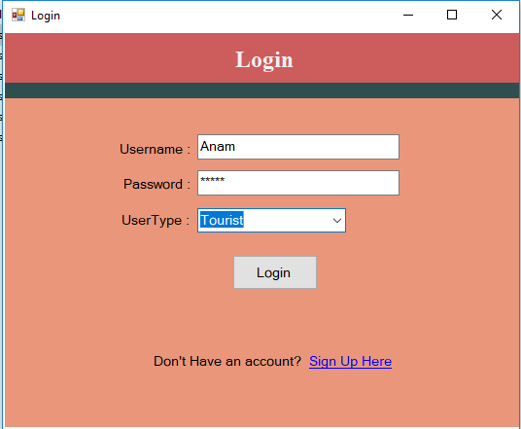

Figure: Login Page

1. If you are not an user, then you have to click Sign Up Here

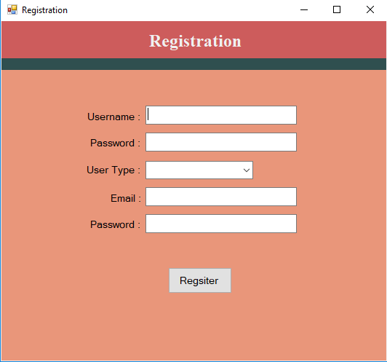

Figure: new user registration form

1. The categories of a user are given in –

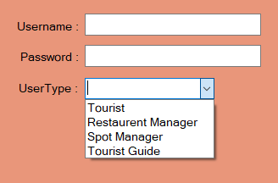

Figure: user categories

1. This is the tourist page

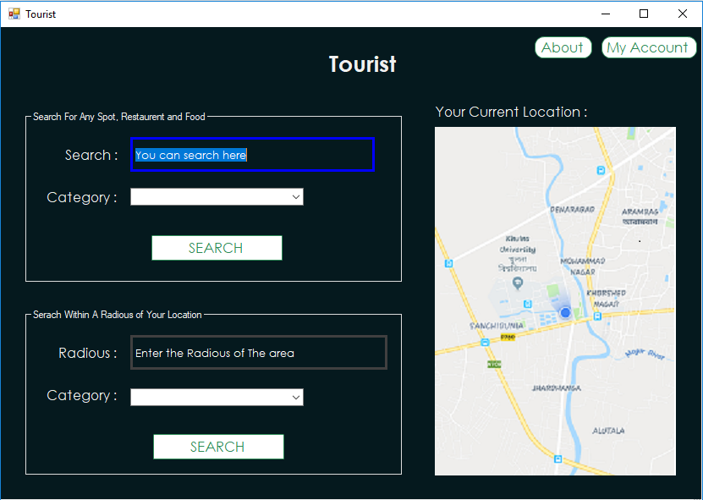

Figure: Tourist Page

1. Tourist can search spots, restaurants, foods from any place by this form

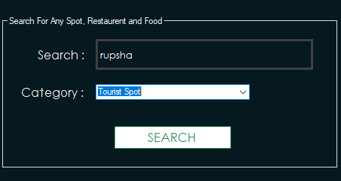

Figure: Tourist Search Option

1. List of all the tourist spots of rupsha

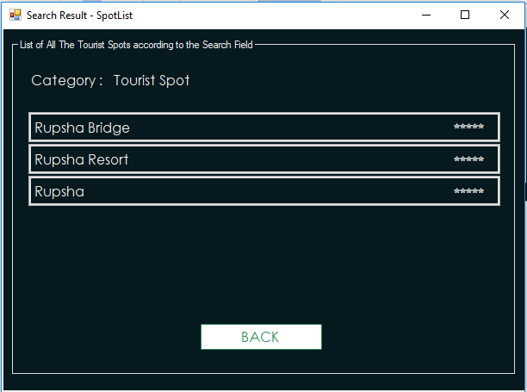

Figure: search results of rupsha

1. The details view of a tourist spot (rupsha bridge)

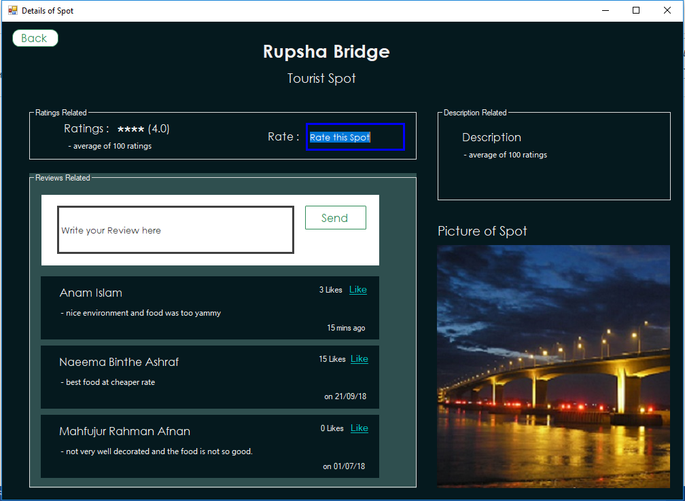

Figure: Rupsha Bridge (Tourist Spot )

1. Search section of tourist in a particular area.

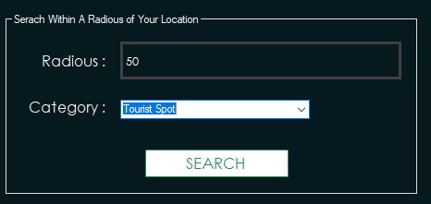

Figure: search option for tourist in his current location among a radius

1. List of all the restaurants according to mezban

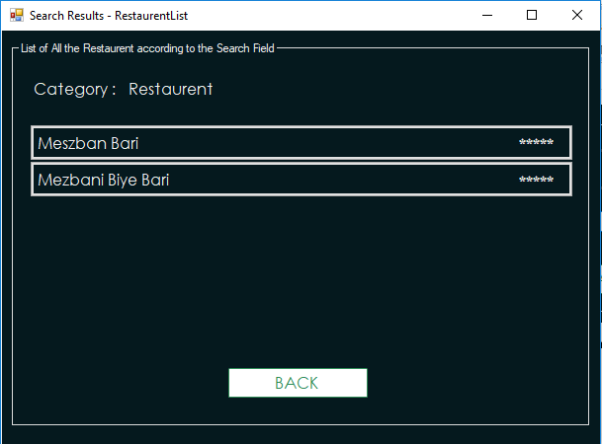

Figure: Search results (Mezban Bari)

1. UI of Mezban bari (View of details of a Restaurant)

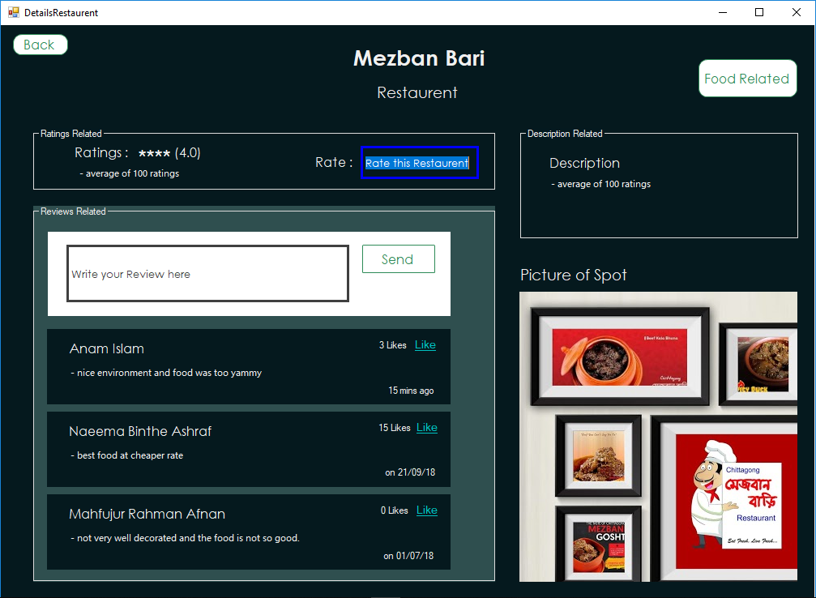

Figure: Details of The restaurant of Mezban Bari

1. The UI of Restaurant Manager is given below.

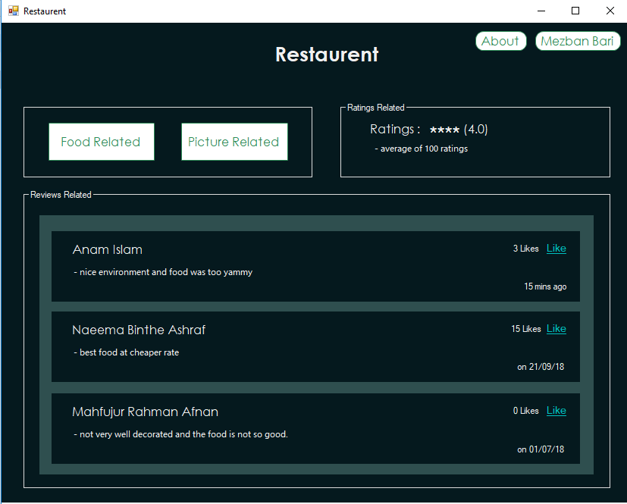

Figure: Restaurant manager page